Which firefox – where program located.

Gedit – linux notepad – text editor

Cd – change directory

Ls – list all files and folder

Echo hi

Echo -n -e “ `date +%T` `sleep 1` \b\b\b\b\b\b\b\b”

Espeak-ng hello

* + Text to Speak (TTS)

Watch -n 1 date  
ctrl +z – Pause program / put it in bg

Jobs – to see bg processes

Fg <id>

Man – to read manual

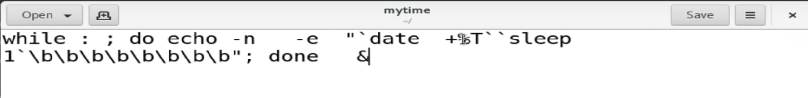

IP

192\*2^24 + 168\*2^16 + 1\*2^8 + 196 \*12^0 = 2899945412

Nslookup – convert hostname into IP

BC – binary calculator

Gnome-terminal – It will launch terminal for you.

Ps-aux – To see process running in the system.

Kill – To stop – kill running process

Touch – To create empty file.

Os.system(“date”) – Run Base OS command in python.

> f.txt – this will create a new file.

Useradd jack – You can create new user.

Passwd jack – Set password for jack user.

Id jack – You can verify user is created or not.

Rm /etc/passwd.lock – If you will not able to create a new user.

Whoami – To see login from which user.

Ctrl (left) + alt + f1 – To change terminal

Chvt 5 – behind the shortcut this command is used.

Startx – to convert CLI into GUI.

Tput setaf 3 – change colour of text

Tput setab 2